Zahava Gopin

4/5/2023

Web335: assignment 4.3

Write a query to display all of the documents in the user’s collection

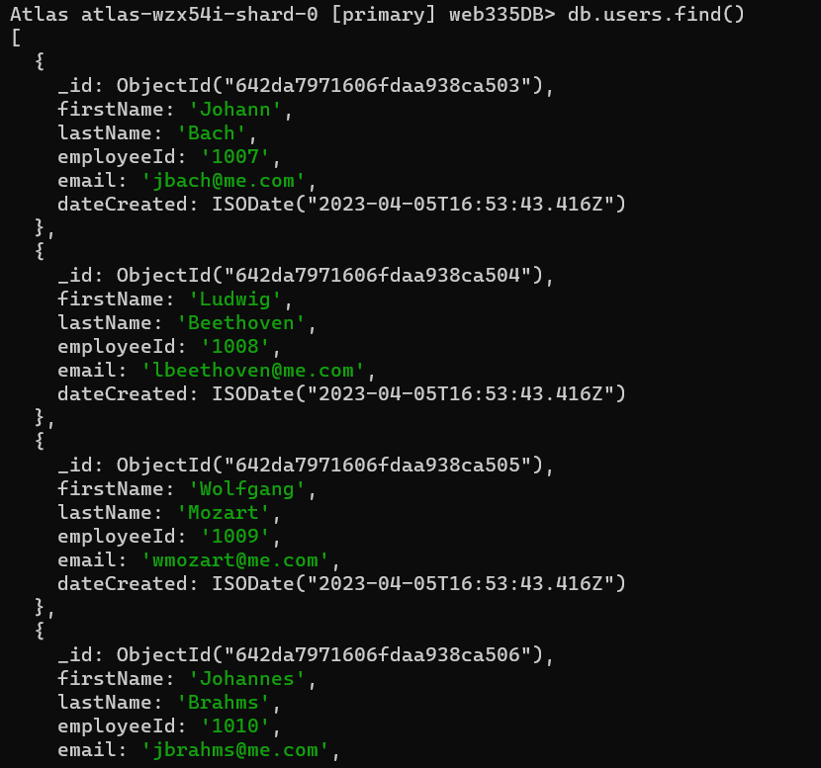

Write a query find the user with an email address of [jbach@me.com](mailto:jbach@me.com)

Write a query to find a user with the last name of Mozart

Write a query to find a user with a first name of Richard

Write a query to find a user with an employeeId of 1010

